## Project Design Phase-II

**Data Flow Diagram & User Stories**

|  |  |
| --- | --- |
| 📅 Date | 31 January 2025 |
| 👥 Team ID | LTVIP2025TMID31117 |
| 👥 Team Size | 4 |
| 👑 Team Leader | Sai Vinay Biruda |
| 👤 Team Members | - Pilli J V Durga Prasanna Kumar  - Pradeep Kumar  - Pattucharla Lakshmi Anjana Sridevi |
| 📌 Project Name | Workforce Administration Solution (Dev) |

### Data Flow Diagram

#### Context Level DFD Description

The data flow diagram represents how data moves through the Workforce Administration Solution. Key flows: - HR Administrator enters and manages employee, project, and asset data. - System processes assignments and updates records. - Project Manager accesses reports and dashboards. - Employees view their assigned projects and assets. - Data stored securely in Salesforce database.

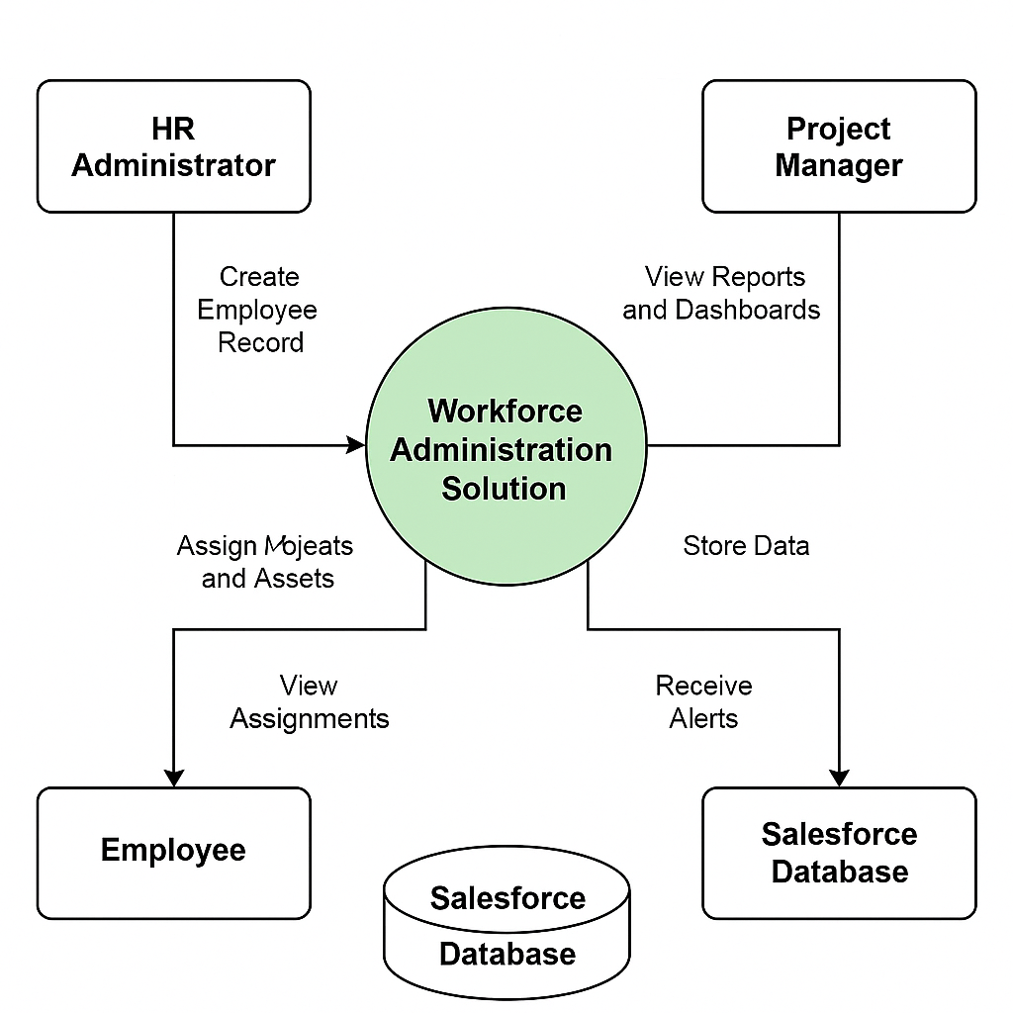

### User Stories

| User Type | Functional Requirement (Epic) | User Story Number | User Story / Task | Acceptance Criteria | Priority | Release |
| --- | --- | --- | --- | --- | --- | --- |
| HR Administrator | Employee Management | USN-1 | As HR, I can create and edit employee records in the system. | Employee records are saved and viewable. | High | Sprint-1 |
| HR Administrator | Project Assignment | USN-2 | As HR, I can assign employees to projects. | Project assignments are reflected in reports. | High | Sprint-1 |
| HR Administrator | Asset Assignment | USN-3 | As HR, I can assign assets to employees. | Asset assignments are recorded accurately. | High | Sprint-1 |
| Project Manager | Dashboard Access | USN-4 | As PM, I can view team workload and assignments on dashboards. | Dashboard displays real-time data. | High | Sprint-1 |
| Employee | Assignment View | USN-5 | As an employee, I can view my assigned projects and assets. | Employees can access their assignment records. | Medium | Sprint-2 |
| System | Overdue Alerts | USN-6 | As the system, I send alerts for overdue asset returns. | Alerts are sent on due dates. | Medium | Sprint-2 |
| Administrator | Reporting | USN-7 | As an admin, I can generate audit-ready reports. | Reports can be exported and shared. | High | Sprint-1 |